Python Code
import numpy as np
import matplotlib.pyplot as plt

# Number of simulations
simulations = 10000

# Estimated probability of fintech competition affecting revenue
probability = 0.60

# Estimated financial impact range (in millions)
min_loss = 50
max_loss = 300

# Random loss outcomes
losses = np.random.uniform(min_loss, max_loss, simulations)

# Random probability events
events = np.random.rand(simulations)

# Apply probability condition
simulated_losses = np.where(events < probability, losses, 0)

# Calculate statistics
mean_loss = np.mean(simulated_losses)
max_loss = np.max(simulated_losses)
percentile_95 = np.percentile(simulated_losses, 95)

print("Average Expected Loss (Millions):", round(mean_loss,2))
print("Maximum Loss Scenario (Millions):", round(max_loss,2))
print("95th Percentile Loss (Millions):", round(percentile_95,2))

# Plot distribution
plt.hist(simulated_losses, bins=50)
plt.title("Monte Carlo Simulation of Fintech Competition Risk")
plt.xlabel("Loss in Millions ($)")
plt.ylabel("Frequency")
plt.show()

The outcome of the Code
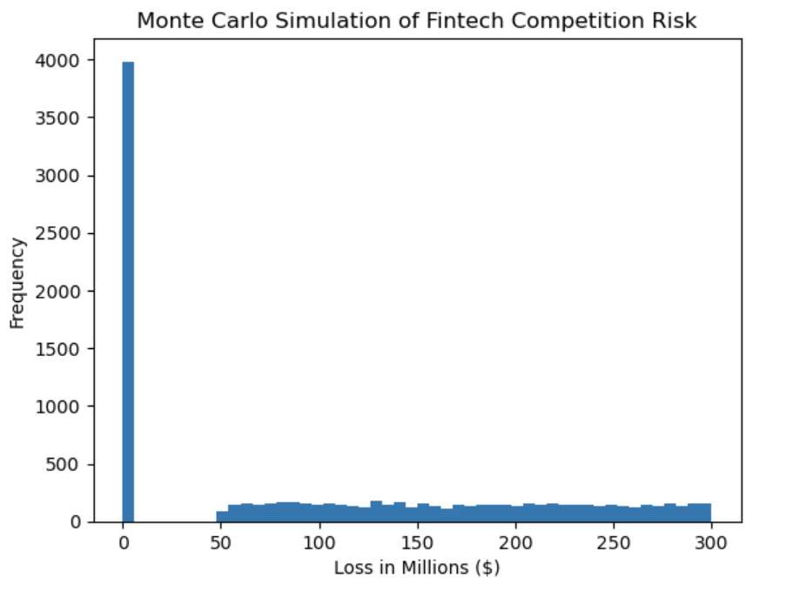
The simulation generated 10,000 possible financial loss scenarios resulting from fintech competition. The model estimates the expected financial exposure based on probability and potential loss ranges. The results help identify the average expected loss, the worst-case loss scenario, and the 95th percentile risk level. These insights allow management to better understand uncertainty surrounding competitive disruption and support proactive strategic planning.

Conclusion
This quantitative risk assessment extends the previous Manulife heat map analysis by applying the Indicators and Warning (I&W) technique to three high-priority risks. By linking each risk to measurable indicators and calculating probability-impact values, the organization can monitor early warning signals and detect increasing risk exposure before major disruptions occur.
The analysis confirms that fintech competition represents the most significant strategic risk, followed by major technology failure and cybersecurity vulnerabilities. These risks require continuous monitoring due to their potential to affect operational resilience, regulatory compliance, and customer trust.
Combining heat map analysis, quantitative modeling, and I&W monitoring provides a comprehensive framework for proactive risk management and supports stronger decision-making within Manulife’s enterprise risk management program.

References
Deloitte. (2023). Global insurance outlook.
IBM Security. (2023). Cost of a data breach report.
International Organization for Standardization. (2018) . ISO 31000: Risk management guidelines.
World Economic Forum. (2023). Global risks report.

